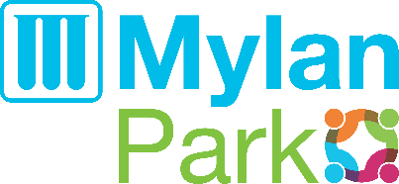
The Aquatic Center at Mylan Park
1847 Fitness Way Morgantown, WV 26501
www.mylanpark.org/aqua

CAMP/GROUP RESERVATION FORM 2021
Please use this form to request the use of the community Pool at the Aquatic Center at Mylan Park. Indicate your group’s size and preferred time slot. Every effort will be made to accommodate your request. Requests will be assigned based on space availability and bather load limitations. To better meet your request, please provide all the information requested in the table below (Please type or print):
For Profit Non-Profit Camp*
Organization Name: |  | Camp Name (If different):
Camp Director/Contact Person(s): |  | Mailing Address:
Phone Number: | Cell/Phone: |  |  |  | E-mail:
Time(s) Requested (circle): 12:30-2pm 2:15-3:45pm 4-5:30pm
Date(s) Requested (list all):
Total Number of Days: |  |  | Average Number of Participants per visit: Select One
Average #of Participant by age:  Please give us your best estimate. This will assist in assigning adequate space. |  |  |  | Under 6 |  | Under 8 | Under 10 |  | Under 12
Camp Fees Calculation – Camp Fees are Not-Refundable
Number of Campers |  | 20-30 |  | 30-40 |  | 40-50 | 50-60 |  | 60+
Camp Daily Fee: For Profit Camps |  | $150 |  | $200 |  | $225 | $275 |  | N/A
Camp Daily Fee: Non- Profit Camps |  | $100 |  | $130 |  | $150 | $200 |  | N/A
Booking Fee: (# Days) x $10 =  Non-Refundable fee.  Payable by credit card at time of request. |  |  | Camp Daily Fee: (# Days) =  Total Due on the day of the swim or before:

- All groups seeking a Non-profit discount on Camp fees must submit a current copy of IRS Form 501(c) along with the booking request.
- Groups must NOT exceed 60 campers. Groups exceeding 60 children will only be allowed to admit 60 kids
I am aware of the risks involved in the use of the Aquatic facility, including but not limited to theft or damage to personal property, and the risk of serious personal injury or drowning. While lifeguards are on duty, I am aware that I am responsible for my own and my camp participant’s safety and will swim only in areas appropriate to my or their skill level. By signing below, I agree to the Waiver of liability on page 2 of this document and have read and understand it’s entire contents and agree to hold harmless the facility and it's agents.

Signature Camp Director (on behalf of the Organization) Date

